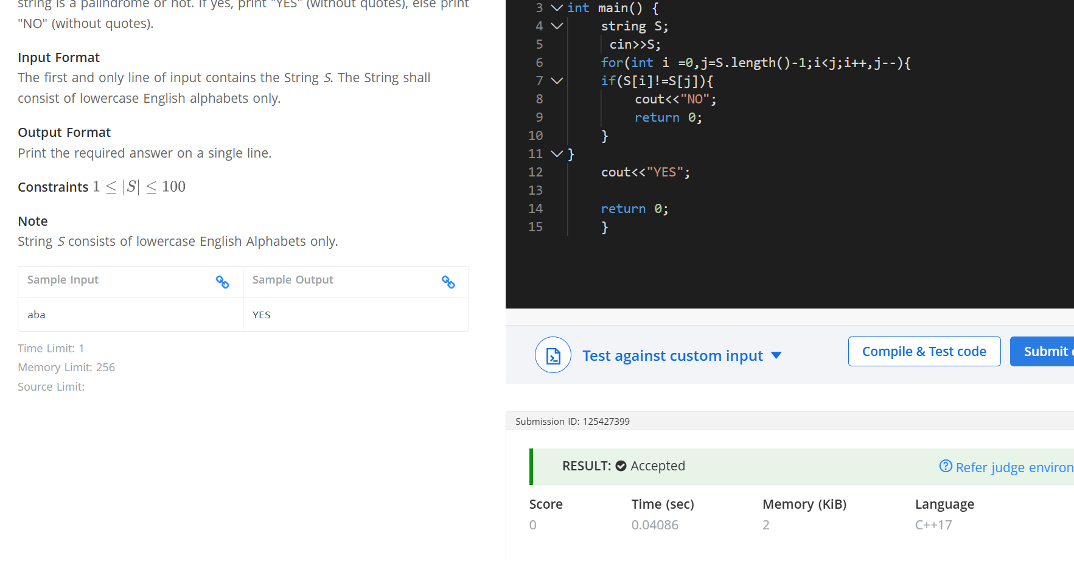
Q Palindrome string
#include <iostream>
using namespace std;
int main() {
string S;
cin>>S;
for(int i =0,j=S.length()-1;i<j;i++,j--){
if(S[i]!=S[j]){
cout<<"NO";
return 0;
}
}
cout<<"YES";

return 0;}

